**Appointment system.**

**There can be many users using our appointment system. We have a lot of clinics onboarded along with their doctors. A doctor can go to multiple clinics. A user can book an appointment to a doctor going to a particular clinic by choosing a time.**

**Design a single database, add relevant optimisations and write optimised queries for the cases stated.**



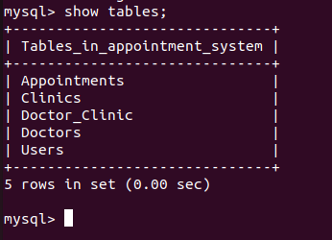

**1. All appointments booked in last 7 days for a doctor**

SELECT *

FROM Appointments

WHERE doctor_id = 1

AND appointment_time >= CURDATE() - INTERVAL 7 DAY;

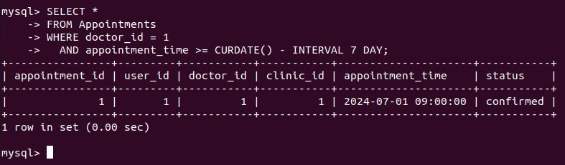

Retrieves all appointments for a specific doctor (doctor_id = 1) that occurred within the last 7 days using CURDATE() and INTERVAL 7 DAY.

**2. All appointments booked in last 2 days n scheduled within next 5 hours for a doctor**

SELECT *

FROM Appointments

WHERE doctor_id = 2

AND appointment_time BETWEEN CURDATE() - INTERVAL 2 DAY AND NOW() + INTERVAL 5 HOUR;

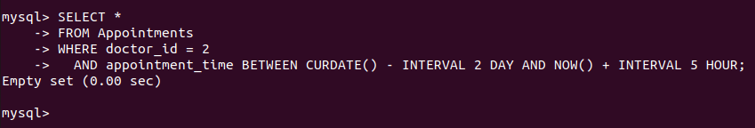

Fetches appointments for a specific doctor (doctor_id = 2) that were booked within the last 2 days (CURDATE() - INTERVAL 2 DAY) and are scheduled to occur within the next 5 hours (NOW() + INTERVAL 5 HOUR).

**3. User who have atleast 1 appointment and have their birthday coming in next 5 days.**

SELECT *

FROM Users

WHERE user_id IN (

SELECT DISTINCT user_id

FROM Appointments

)

AND DATE_FORMAT(CURDATE(), '%m-%d') <= DATE_FORMAT(DATE_ADD(birthday, INTERVAL 5 DAY), '%m-%d')

AND DATE_FORMAT(CURDATE(), '%m-%d') >= DATE_FORMAT(birthday, '%m-%d');

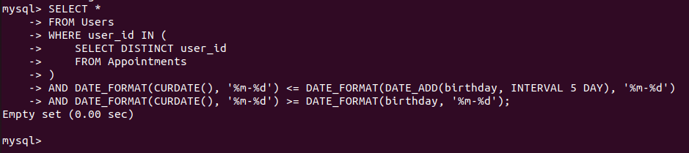

Retrieves users from the Users table who have at least one appointment (user_id present in Appointments table) and whose birthday (birthday) falls within the next 5 days relative to today (CURDATE()).

**4. Appointments for a particular patient in the last 7 days**

SELECT *

FROM Appointments

WHERE user_id = 3

AND appointment_time >= CURDATE() - INTERVAL 7 DAY;

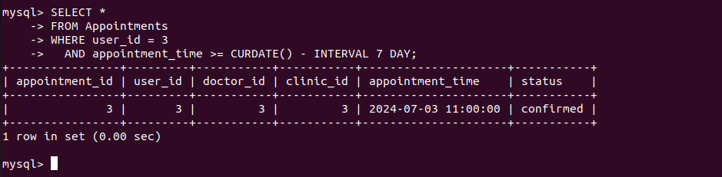

Fetches all appointments for a specific patient (user_id = 3) that occurred within the last 7 days using CURDATE() and INTERVAL 7 DAY.

**5. Appointment cancellation percentage for a doctor by clinic**

SELECT

clinic_id,

doctor_id,

(SUM(CASE WHEN status = 'canceled' THEN 1 ELSE 0 END) / COUNT(*)) * 100 AS cancellation_percentage

FROM Appointments

WHERE doctor_id = 4

GROUP BY clinic_id, doctor_id;

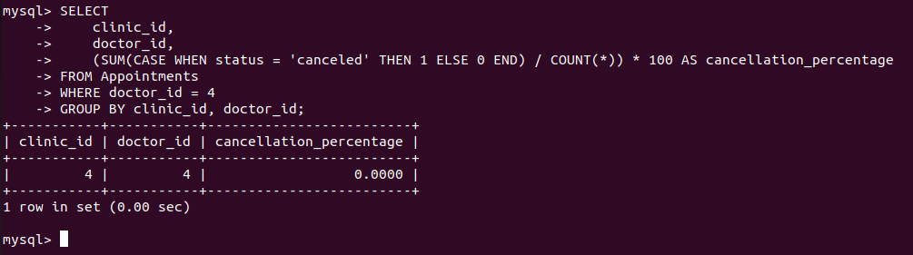

Calculates the cancellation percentage for appointments scheduled by a specific doctor (doctor_id = 4) across different clinics (clinic_id). It computes the ratio of canceled appointments to total appointments and expresses it as a percentage.

**ER - DIAGRAM**

